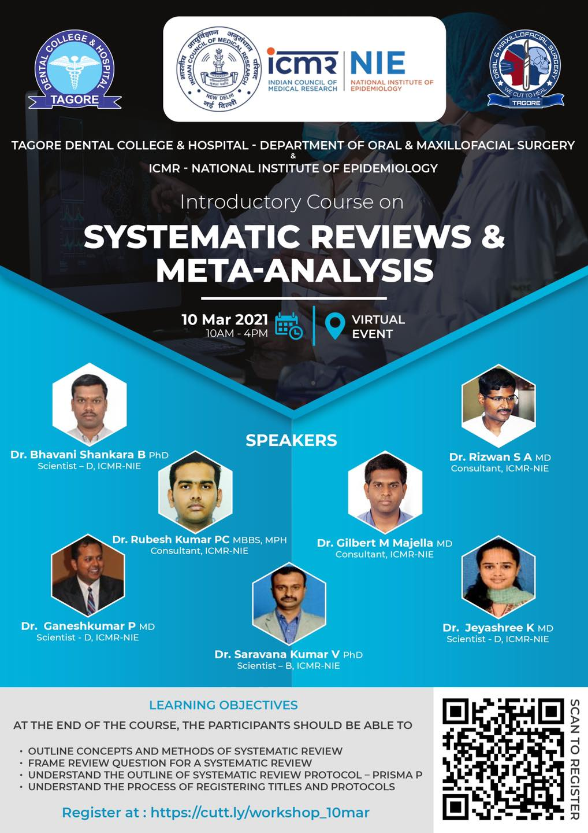

TAGORE DENTAL COLLEGE AND HOSPITAL
MELAKOTTAIYUR POST, RATHINAMANGALAM
CHENNAI – 600127
PH: 044 – 3010 2222, EXTN: 228 / 230
EMAIL ID: maxfacs@tagoredch.in

PROF.M.MALA DR.CHITRAA R. CHANDRAN
CHAIRPERSON PRINCIPAL

DR.MANOJ V.MURHEKAR
DIRECTOR AND SCIENTIST-G
NATIONAL INSTITUTE OF EPIDEMIOLOGY (ICMR)

ORGANIZING COMMITTEE:
PROF.DR.S.JIMSON
DR.J.PARTHIBAN
DR.B.LOKESH
DR.B.ANANDH
DR.MEERAN SHARIF
DR.VINAY SUNDAR
DR.ISRAEL NATHANAEL

REPORT ON “BIOETHICS AND RESEARCH INTEGRITY WORKSHOP “– 17th December 2020”
Title of the CDE Program: SYSTEMATIC REVIEW AND META-ANALYSIS (VIRTUAL)
Organizer: Department of Oral and Maxillofacial Surgery, Tagore Dental College and Hospital.
Date: 10th MARCH, 2021
Learning Outcome: To acquire detailed knowledge on Systematic Review and Meta-analysis.
Venue: Conducted online through CISCO WEBEX application.

Guest Speakers:
- Dr. Bhavani Shankara .B
Scientist –D, ICMR NIE

- Dr.Rizwan Suliankatchi .A
Consultant, ICMR NIE

- Dr.Rubesh Kumar PC
Consultant, ICMR NIE

- Dr. Ganesh Kumar.P
Scientist –D ICMR NIE

- Dr. Saravana Kumar
Scientist –B ICMR NIE

- Dr. Gilbert M .Majella
Consultant ICMR NIE

7. Dr. Jayshree .K
Scientist –D ICMR NIE

TOPICS COVERED:
- OUTLINE CONCEPTS AND METHODS OF SYSTEMATIC REVIEW
- FRAMING REVIEW QUESTIONS FOR SYSTEMATIC REVIEW
- UNDERSTAND THE OUTLINE OF SYSTEMATIC REVIEW PROTOCOL- PRISMA P
- UNDERSTANDING PROCESS OF REGISTERING TITLES AND PROTOCOLS

SCHEDULE for 10-3-2021 “ systematic review and meta-analysis
Program | Time | Speakers
REGISTRATION | ONLINE | DONE ONLINE
WELCOME ADDRESS | 9.45AM – 9.50AM | DR.S.JIMSON
INTRODUCTORY SPEECH | 9.50AM – 9.55AM | DR.CHITRA R. CHANDRAN
LECTURE 1 | 10.00AM – 10.30AM | DR.BHAVANI SHANKARA
OVERVIEW OF SYSTEMATIC REVIEW AND META-ANALYSIS
LECTURE 2 | 10.35AM – 11.05AM | DR.RIZWAN SULIANKATCHI
FRAMING THE REVIEW QUESTION
TEA BREAK | 11.05AM – 11.30 AM
LECTURE 3 | 11.30AM – 12.05PM | DR.RUBESH KUMAR.PC
FRAMING THE ELIGIBILITY CRITERIA
LECTURE 4 | 12.10PM – 12.40PM | DR.GILBERT M. MAJELLA
SOURCES OF LITERETURE
LUNCH | 12.40PM – 1.15PM
LECTURE 5 | 1.15PM –1.45PM | DR.GANESH KUMAR
STRATEGIES FOR SEARCHING EVIDENCE
LECTURE 6  SCREENING , SELECTION AND DATA ABSTRACTION PROCESS | 1.50PM-2.20PM | DR.JAYASHREE
TEA BREAK | 2.20PM TO 2.45PM
LECTURE 7  ASSESSING BIAS AND DATA SYNTHESIS | 2.50-3.20PM | DR.SARAVANA KUMAR.V
LECTURE 8

PRISMA -P AND PROTOCOL REGISTRATION | 3.25-4.PM | DR.GANESH KUMAR .P  DR.RIZWAN SA
VALEDICTORY SESSION | 4.15PM-4.30 | DR.S.JIMSON
THANK YOU NOTE | 4.30-4.35PM | DR.S.JIMSON

Welcome address was given by Prof.Dr.S.Jimson. The Principal Prof.Dr.Chitraa R. Chandran addressed the gathering and gave an insight into the scope of the program.
The first lecture started at 10 am and was given by Dr.Bhavani Shankar, Scientist – D, ICMR, NIE, on the topic “Overview of systematic review and meta-analysis. The lecture was followed by a discussion session.
The second lecture was presented by Dr.Rizwan Suliankatchi, Consultant, ICMR, NIE, on the topic “Framing the Review Question”. The lecture was followed by a discussion. A short tea break of 25 minutes was allowed after the second lecture.
The third lecture of the program started by 11.30 am. The lecture was presented by Dr.Rubesh Kumar.PC on the topic “Framing the eligibility criteria”. The lecture was followed by a discussion.
The Fourth lecture was presented by Dr.Gilbert M. Majella, on the topic “sources of literature”.
The lunch break was provided between 12.40pm - 1.15pm.
Fifth lecture was given by Dr.Ganesh Kumar, on the topic “Strategies for searching evidence”. The lecture was followed by a discussion.
The sixth lecture was by Dr.Jayashree, on the topic “Screening, selection and data abstraction process”. Following the lecture there was a discussion session. The seventh lecture for the day was given by Dr.Saravana Kumar.V, Scientist-B, ICMR-NIE, on the topic “Assessing bias and data synthesis”. The lecture was followed by a discussion session.
The eighth lecture was given by Dr.Ganesh kumar .P and Dr.Rizwan SA on the topic “PRISMA -P and protocol registration”. The lecture was followed by a discussion session.
The program was attended by 158 members (12 interns, 6 post-graduate trainees and 7 staff members) from Tagore Dental College and 133 members from other institutions both national and international. The program received a good feedback from the participants.

